(Approx. 1392 words)

GNU Octave
By Dick Maybach, Member, Brookdale Computer Users’ Group, NJ
June 2017 issue, BUG Bytes
www.bcug.com
n2nd (at) att.net

Engineers, scientists, and educators use computer math tools extensively, and students would also find these helpful, but their costs are often a barrier. Fortunately, free programs such as GNU Octave (http://www.gnu.org/software/octave/) and Scilab (http://www.scilab.org/) provide similar power to their commercial kin and both are available for Windows, OS X, and Linux. They are modeled after the popular commercial program Matlab (https://www.mathworks.com/), which sells for $50 for the student version and up to $2150 for the standard one. If you are a parent, you may be concerned that if your student uses such a tool, he or she may use it to avoid learning math, but in my experience, this doesn't happen. While teaching engineering, I found that many in my class had not mastered basic math, and I introduced computer tools to provide them with alternate approaches. However, the only students who made use of these were those already skilled in math. Apparently, people who had the initiative and talent to master computer math had already used these same assets to learn what was being taught in the math classroom, and they used the computer tools to gain additional advantages over their slower friends. Life isn't fair.
I'll discuss GNU Octave in this article, mostly because it is closer to the widely-used Matlab than is Scilab; indeed, many Matlab programs will run without change on Octave. Becoming proficient with any math tool takes considerable time, and if possible you should choose one that gives you skills you can transfer later. Octave is basically a programmable scientific calculator; that is, you enter a math relation and it computes a numerical result. Figure 1 shows the program in operation.

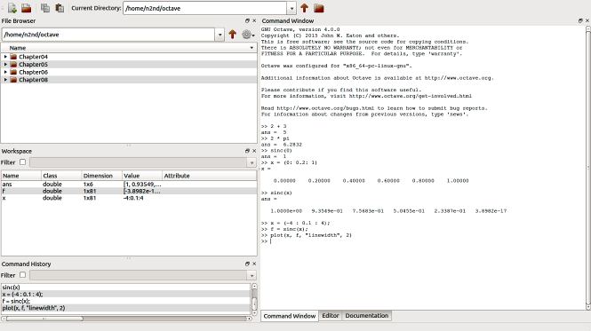
Figure 1. Gnu Octave Window.

Its window has four panes
- upper-left – file browser,
- center-left – workspace, showing the active variables,
- lower-left – command history, and
- right – commands and results.
The command pane is where you work and is essentially a view into a command-line terminal. You can do only primitive editing here, usually with the arrow keys, backspace, and delete, but you can also copy and paste. The “>>” character pair is the command prompt. Note the tabs below the command pane, which give you access to a real editor and extensive help.

Let’s look at the simple examples shown in Figure 1.
- You do simple arithmetic just by entering an expression followed by a tap of the Enter key. Here, we see that 2 + 3 = 5.
- There are built-in constants such as π (“pi” in Octave-speak), which you can use in your expressions, and we see that 2π = 6.2832. Note that multiplication must be declared explicitly using the “*” character.
- Higher-level functions are available, such as sinc(x), which is defined as sin(π x)/(π x), except that sinc(0) is defined as 1.0. (This exception is needed because 0/0 isn’t defined.) Figure 1 shows this verified.
- When using Octave, you will often be working with vectors, arrays, and matrices, and there are shortcuts to help in defining these. The example shows one, where x = (0 : 0.2 : 1) defines x as an array with values starting at 0, increasing by 0.2, and ending at 1.
- We can use this array as an argument for sinc, to find sinc(x) for x = 0, 0.2, 0.4, 0.6, 0.8, and 1.0.
- Finally, we can redefine x to be an array with values from -4 to +4 and separated by 0.1 and plot the sinc function. (The arguments “linewidth” and 2 make the trace thicker than its default, which I felt was too thin.) The result appears in Figure 2.

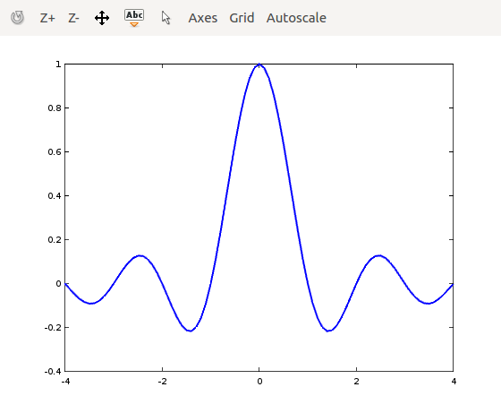
Figure 2. Plot of the sinc function.

You can often gain more insight from a simple plot than from an expression or a table of values.

Let’s show a more complex example using the sinc function, as shown in Figure 3.

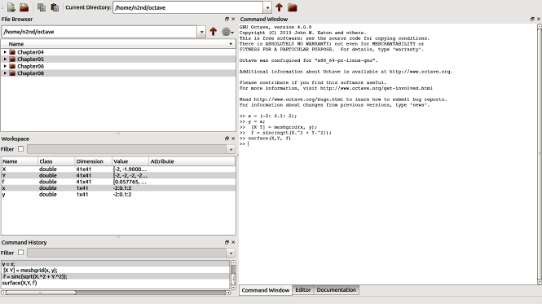
Figure 3. Three-dimensional Plotting Commands.

Figure 3 shows the following steps. (If your math is rusty, the details may be gibberish, but that’s unimportant. The point here is that defining a plotting complex functions is easy and provides insight that is difficult to achieve by just looking at the expressions.)
- Define an array x with values from -2 to +2 in steps of 0.1. (The semicolon at the end of the line prevents printing the 41 values.
- Define a second array y with the same values as x.
- Define a two-dimensional array [X Y] with each element being a pair of numbers from x and y. Its top row is (-2, 2), (-1.9, 2), … (2, 2); its second row is (-2, 1.9), (-1.9, 1.9), … (2, 1.9); and so on.
- Evaluate sinc for every element of [X Y]. Note that the expression X.^2 causes the elements of the array to be squared individually. If instead we had used X^2 (without the “.”), we would have multiplied the entire array of X values by the same array. With the operation shown, f is a 41 by 41 array whose elements are the sum of the squares of the elements of [X Y]. This is shown in the Workspace pane.
- Finally, we make a surface plot of the result, shown in Figure 4. (The button at the upper-left corner of the screen enables rotating the plot by dragging its corners.)

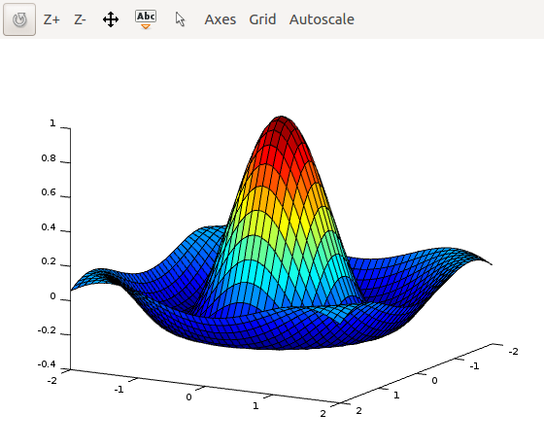
Figure 4. Surface Plot of the Sinc Function.

Octave can also solve simultaneous linear equations (beloved by algebra teachers and feared by their students). Figure 5 shows an example.

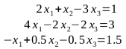
Figure 5. Simultaneous Equations.

We can restate this, using matrix notation, as Ax = b, where the matrices are defined as shown in Figure 6. Compare Figures 5 and 6 and you’ll see that A contains the coefficients of the equations. Its top row holds those of the top algebraic equation and so on. Matrix b is similarly defined by the constants on the right.
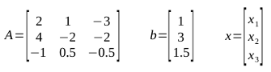
Figure 6. Simultaneous Equation Matrix Definitions.

Again, using matrix notation, the solution is x = A⁻¹b, where the -1 exponent indicates that the matrix A is inverted. (Using Octave commands, this becomes be x = inv(A)*b.) Finding the inverse of a matrix, even only a 3 by 3 one, using paper and pencil is time-consuming and error-prone. As a result, those of us who were educated BC (before computers) relied on algebra instead. All this changed when personal computers and mathematics programs became available. Figure 7 shows this problem solved using Octave.

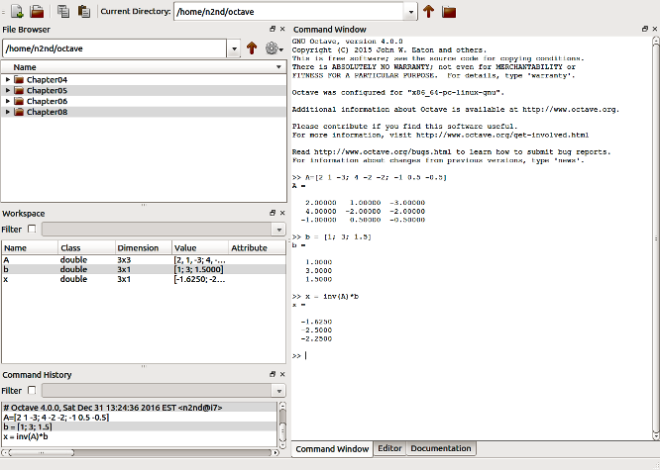
Figure 7. Simultaneous Equation Solution Using Octave.

As you can see, it required entering only three lines, one to define A, one to define b, and one to request the solution, which is x₁ = -1.6250, x₂ = -2.5, x₃ = -2.25.

This has been a brief introduction to Octave with the goal of letting you know what it is and the sorts of things it can do, and I’ve covered only a very few of its capabilities. In particular, I haven’t discussed Octave programs, which you can write to solve complex problems. Although it can’t compensate for a lack of math skills, it can be invaluable for those that have them. There are many applications packages that add additional capabilities. These are listed on the Octave Website, and some are discussed in the references below.

A good starting tutorial for learning more is the 280-page GNU Octave Beginner's Guide (http://jordi.platinum.linux.pl/octave/Jesper%20Schmidt%20Hansen%20-%20GNU%20Octave%20for%20Beginners.pdf), which you will also see available in print. The user interface has evolved since this was written, but the commands are unchanged and its examples work. Also, see the 300-page and more up-to-date Octave at BFH-TI Biel (http://web.ti.bfh.ch/~sha1/Labs/PWF/Documentation/OctaveAtBFH.pdf). It shows the current user interface, but has a more academic approach than the Beginner's Guide. Unfortunately, both documents don't always use standard ASCII characters. For example “*” is not always the asterisk that Octave uses for multiplication. As a result, pasting the examples into the program often produces errors, but you will quickly find what to look for. The official manual is the 1000-page GNU Octave (https://www.gnu.org/software/octave/). This too is up-to-date, but its heavy reading and is a command reference rather than a tutorial. Finally, an Internet search will turn up several getting-started guides.

A math program like Octave won’t compensate for deficient math skills, but it will add insight and speed up finding solutions for those who already have them.

